(Approx. 725 words)

Waymo Self-Driving Cars

by Jeff Wilkinson, President, Sun City Summerlin Computer Club
https://www.scscc.club

president.scscc (at) gmail.com

On a recent visit to San Francisco, we noticed Waymo cars on many downtown streets. At first, we thought it was part of Google maps since Waymo is an Alphabet company, Google's parent company. But after seeing multiple Waymo cars together, we, you guessed it, Googled it and found out it was a ridesharing service.

The Waymo taxi service began in Phoenix shortly after mapping the greater Phoenix area was completed in October 2020. This driverless service was previously available only to research testers and onboard safety drivers. Now, it serves a 50-square-mile area in the Phoenix suburbs of Chandler, Tempe, and Mesa. With a huge investment at stake, the challenge is to reduce the amount of human interaction required to safely perform the service.

At this time, San Francisco is in Beta testing, initially offering free rides to select passengers in San Francisco via its Trusted Tester program. Waymo's fleet includes Toyota Priuses and hybrid Chrysler Pacificas, but, Waymo has partnered with Jaguar to deliver the world's first fully self-driven premium EV experience. We saw only these vehicles in San Francisco.

Because San Francisco's terrain is hilly, with dense streets and multiple obstacles from continuous construction activity, Waymo cars will have a safety driver on board. The team has been mapping the city since 2019, and the cars contain 5 LiDARs (Light Detecting and Ranging) and one surround-view camera on top of each vehicle. LiDARs provides a detailed, 3D map of the car's surroundings. It gives shape and depth to the objects, roads, buildings, and more—the data from these sensors is fed to a computer running Google's machine learning algorithm.

The human body has five senses, hearing, sight, smell, taste, and touch. We use these senses to navigate the world we live in. Some of these senses are detected with man-made sensors in self-driving cars. Cameras for sight, taking multiple photos to be compared with known objects using the computer algorithm. Cameras are used with object detection algorithms to classify all the things the car sees into usable data for the algorithm. The cameras are also placed for a 360-degree view and are adapted for identification in various light and climate conditions. Once the camera has gathered the data, an object detection algorithm, which involves computer vision and neural networks, is used to classify the objects into labels like pedestrians, cars, signs, and more.

LiDAR is used to simulate the touching sense and provide range and distance information. The camera can rotate at hundreds of revolutions per minute and provide a 360-degree view and high-resolution information range. The vertical angle of detection allowing height measurement and the updating frequency are other important features. In addition, multiple channels with input from different laser beams provide higher quality data to the object detection algorithm.

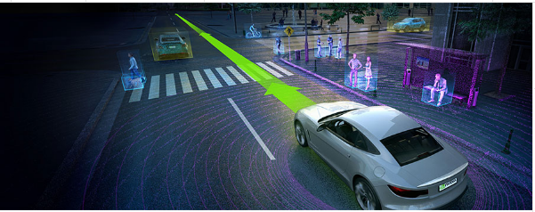
The Waymo driver uses the information it has gathered, along with its over 20 million miles driven in the real world, to predict where other objects (like pedestrians, cars, etc.) would go, how fast they would move, and the way they move.

It predicts all the possible paths each object may take in less than a second. With constant updates and corrections as the trip begins.

In addition to safety and navigation, self-driving vehicles must be power-and-fuel-efficient. Therefore, numerous sensors, actuators, application-specific circuit boards, and subsystems are installed in self-driven cars to manage system-level operations, power consumption, and fuel efficiency.

The voltage in the vehicle battery is crucial for the safety of the users and the vehicle's functionality and is constantly monitored. Autonomous cars use milliohm meters and shunts feeding differential amplifiers to precisely measure the battery voltage drop.

Actuators, step motors, and solenoid valves in the electronic fuel injection system help improve fuel efficiency and reduce emissions and are also actively monitored and controlled.

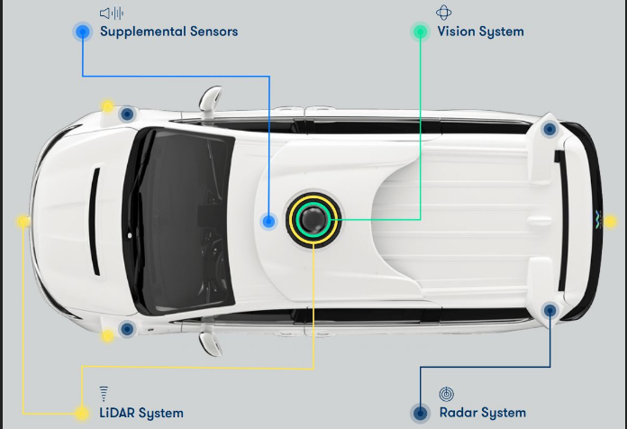
Self-driving vehicles depend on sensors, actuators, and processors to make crucial decisions on the road, ensuring the safety and comfort of their users.

So, these self-driving Waymo Jaguars with the odd-looking spinning lidar and cameras are rolling technology hubs with dynamic inputs feeding various actuators and solenoids, which are constantly updated by feedback from even more sensors!!

Initial tests yielded less than stellar feedback, but progress is steadily being made, which is not surprising given the complexity of the project!!

